REQUEST FOR EXPRESSIONS OF INTEREST -
PROPOSALS TO OCCUPY COUNCIL OWNED PROPERTY
Camden Council is calling for written Expressions of Interest for the occupation of the following Council owned property.
Property Address | 72 Central Avenue Oran Park  SLT: 5 DP: 270899  Office Spaces – 6, 7 & 8  Located within Oran Park Library – Wanneroo
Occupant Requirement | Not for Profit Community Groups Only
Use | Office Space

Expressions of Interest should be submitted in accordance with the Information and Application package which contains:
- Section 1 – General terms and conditions
- Section 2 – Technical requirements
- Section 3 – Selection Criteria
- Section 4 – Written Submission details
The successful operator for the facility will be selected based on demonstration of how the pre-determined criteria are met as detailed in Section 2 Technical requirements. An evaluation panel will assess submissions and notification will be sent to applicants in relation to the outcome of the process. Council reserves the right to decline any or all Expressions of Interest.
Should you have any questions regarding this Expression of Interest, please email mail@camden.nsw.gov.au.
For further information or to view the office space please contact Blair Avila on 4654 7709.

INFORMATION AND APPLICATION PACKAGE
SECTION 1
GENERAL TERMS AND CONDITIONS OF EXPRESSION OF INTEREST
- Expression of Interest Validity
The offer submitted must remain valid for a period of at least 6 months.

- Selection Criteria
A non-profit organisation is expected to provide Council with all information requested to enable Council to assess the proposed benefit to the Camden community based on the organisation’s merit. This may include but is not necessarily limited to some or all of the following:
- Confirmation of legal entity and ABN.

- Details and copies of any agreements or arrangements with or to any third parties.

- A business plan for the period of the proposed agreement (including any option periods), where available. The business plan should demonstrate the proposed lessee’s or licensee’s capabilities to carry out any items specific to the proposed agreement during the term and provide details and timelines of any maintenance, improvements or enhancements proposed to be carried out, completed and paid for by the Licensee during the term.

- Other benefits (qualitative and quantitative) that may be provided to the wider Camden community.

- Successful Applicants
Operators will be required to enter into a formal agreement with Council and will be required to provide Council with:

- $20 Million Public Liability Insurance;
- Such other insurances as Council reasonably requires depending on the proposed use of the property.

- Disputes
Disputes in respect of any Expression of Interest shall be referred to the person nominated in this document as responsible for administration of the contract.

SECTION 2 – TECHNICAL REQUIREMENTS
- Scope
Expressions of Interest are sought from Not for Profit Community Groups only, to occupy Council owned Office Space in Oran Park Library. The Office Spaces are known as the Wanneroo Offices and comprise of Wanneroo 6, 7 & 8 and a communal kitchenette/break out area.

The office spaces are a shared space with users occupying them on different daily schedules. Therefore, the spaces are only available for specific dates which include the following availabilities:
- Room 6 – Monday
- Room 8 – Wednesday
- Room 7 – Friday

Applicants should be aware that they share the common areas with other groups using the offices.

- Period of Agreement and Renewal
The term of the agreement will be twelve months/one year, which will commence on the signing of the agreement by both parties.

The agreement may be renewed, at the discretion of Council, for a period of up to twelve months/one year.

Council reserves the right to terminate the agreement at any time, by giving at least one months notice.

- Operational Factors to be considered
This section describes the range of elements that form the minimum standard of service Council will require from applicants.

  - Requirements
The applicant must address the following requirements in their proposal:

- Potential community, social and economic benefits;
- Overview of your anticipated clients;
- Intended hours of operation;

SECTION 3 – SELECTION CRITERIA

Operators will be selected on the following criteria:
Organisation Criteria:

- The organisation is one which is not operating for the profit or gain of its individual members, whether these gains are direct or indirect.

- The organisation is a legal entity registered under appropriate legislation.

- The organisation is financially sustainable, with annual financial statements and Annual Reports provided to Council and audited where required as a prescribed association by legislation.

- The organisation complies with relevant legislation governing its activities and holds any licenses or registration certificates require for it to operate.

- The organisation has a committee of management and appropriate governance arrangements with established accountability and reporting methods to members of the organisation and/or to the community.

- The organisation has a constitution or charter that confirms the organisation’s commitment to either the cultural, social and/or recreational wellbeing of the community.

Community Benefit Criteria:

- Use of the facility will increase social engagement and promote health and well-being for the Camden community.

- A plan of the facility’s use is provided including current and projected hours of operation and participant and/or membership numbers.

- The organisation provides a service or a program of activities which can be demonstrated to address an identified cultural, social, recreational or other need in the community.

- The organisation’s promotion and support of volunteers.

- Any other benefit that the Camden community derives from the organisation using offices at Oran Park Library.

SECTION 4 – WRITTEN SUBMISSION DETAILS

- Submission

Please provide a written submission in response to the Standard of Service specified in Section 2 ‘Technical Requirements’.

The information to be provided in the submission is:

- Overview of the functions of the organisation;
- Outline of community, social and economic benefits;
- Capacity to meet requirements, as set out in this document in Section 2 (all elements in section 2 must be addressed in your submission); and
- Experience and future plans for your organisation.

- Summary of attached documents required as part of your EOI

The following documents must be provided for your Expression of Interest to be considered:
- Documents showing ABN;
- Certificate of Incorporation (if relevant);
- Completed Organisation Details (attachment 1);
- Written submissions as outlined above;
- Any documentation supporting your written submission; and
- References – minimum of two.

ATTACHMENT 1 – ORGANISATION DETAILS
All information and documentation requested must be completed and attached for the Expression of Interest to be considered. This includes:
Contact Information
Organisation:
ABN (if applicable):
Are you registered for GST? | ☐ | Yes |  | ☐ |  | No
First Name:
Surname:
Position:
Mobile Number:
Email:
Postal Address:
Suburb: |  |  | Postcode:

ATTACHMENT 2 – 72 CENTRAL AVENUE ORAN PARK IMAGES

Office 8
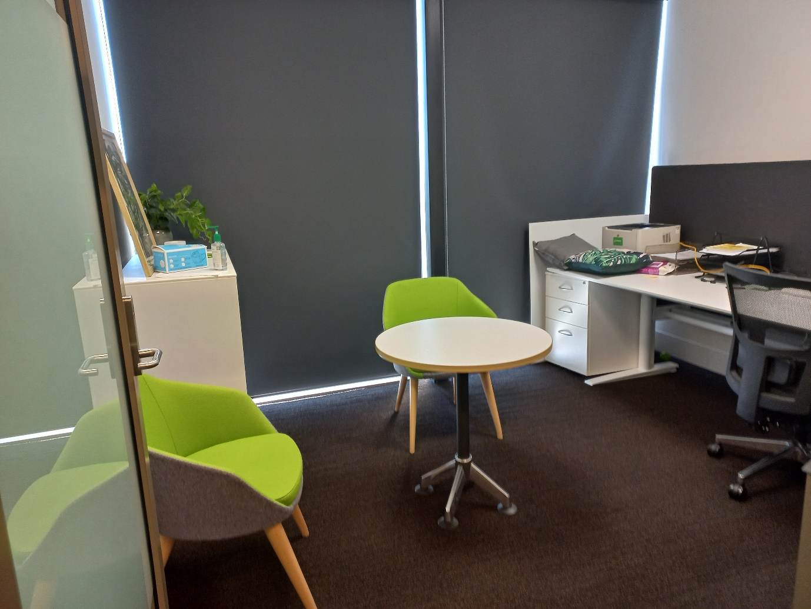

Office 7
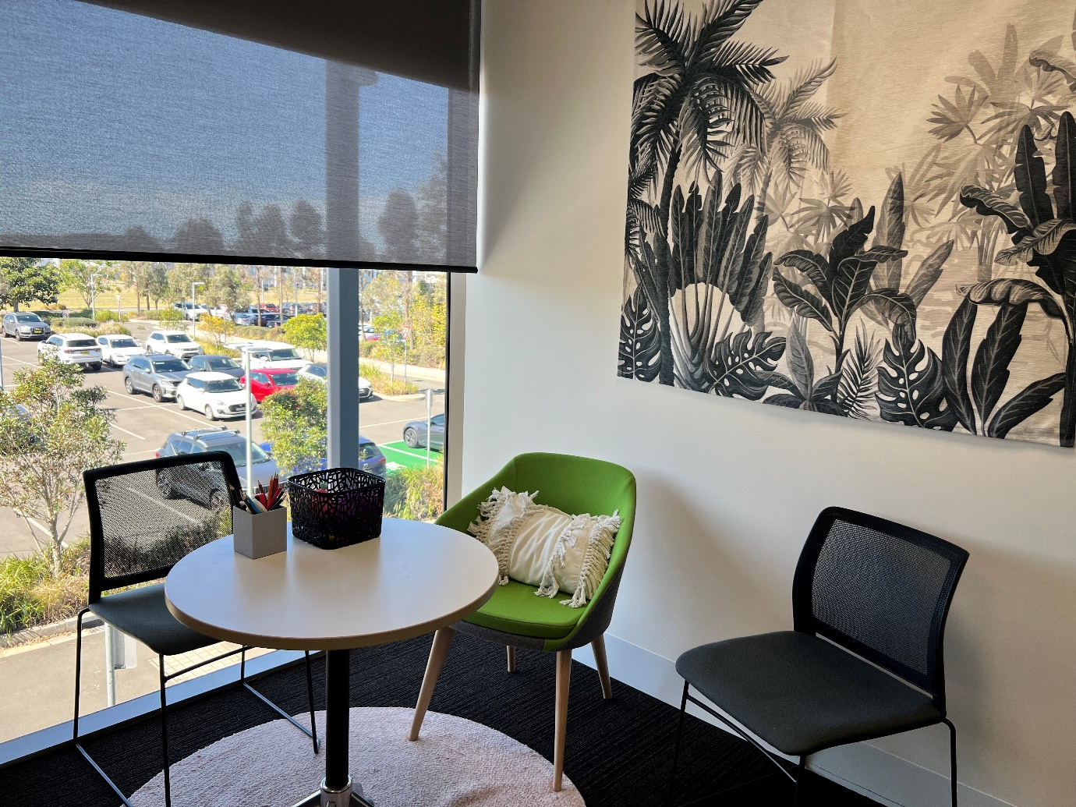

Office 6
